**Draw a Blob Shape - README**

**Overview**

This project is a website that allows users to create custom 2D and 3D shapes by entering coordinates or specifying shape names. It provides an interactive and visually appealing way to generate and display shapes using both the HTML canvas (for 2D) and the Three.js (for 3D).

**Features**

* **Interactive Shape Input**: Users can input vertices in coordinates like (10,10;50,50;90,10) or select predefined shapes by name (e.g., circle, cube).
* **2D and 3D Rendering**: Users can choose between 2D or 3D shape rendering.
* **Shapes** include randome variations to create a more organic, blob-like appearance.

**Technologies Used**

* **HTML/CSS**: For structuring and styling the web page.
* **JavaScript**: For logic, input processing, and drawing shapes.
* **Three.js**: For rendering 3D shapes with interactive animations.

**And it tested via VS code**

**Code Structure**

**1. HTML (index.html)**

The HTML file sets up the structure of the application:

* A container with inputs for vertices or shape names.
* A dropdown to select between 2D and 3D dimensions.
* A canvas for 2D rendering and a div for rendering 3D shapes using Three.js.
* A button to trigger the drawShape function.

**2. CSS (styles.css)**

* Provides a clean, modern look with a responsive design.
* Uses subtle hover and transition effects for interactive elements.
* Styles the canvas and divs to ensure proper rendering and alignment.

**3. JavaScript (script.js)**

Contains the main logic for processing user input and rendering shapes.

* **drawShape() Function**:
  + Fetches user input and selected dimension.
  + Clears previous drawings to ensure new shapes don’t overlap.
  + For **2D Shapes**:
    - Uses the HTML canvas to draw shapes.
    - Adds random coordinates for a blob effect.
    - Supports both custom coordinates and predefined shapes (circle, square).
  + For **3D Shapes**:
    - Utilizes Three.js to set up a scene, camera, and renderer.
    - Supports custom point-based 3D blobs or predefined shapes (e.g., cube, sphere).
    - Adds a light source and material properties for better visualization.
    - Rotates shapes for an animated display.

**How to Use**

1. **Input Coordinates or Shape Name**:
   * Enter vertices in x,y;x,y;... format for custom shapes.
   * Alternatively, input a shape name like circle, square, cube, or sphere.
2. **Select Dimension**:
   * Use the dropdown to choose between 2D and 3D.
3. **Draw**:
   * Click the Draw button to see the shape rendered on the canvas or 3D view.

**Detailed Explanation**

**2D Shape Rendering**

* **Custom Shapes**:
  + Parses user input into coordinate points.
  + Uses context.beginPath() and context.quadraticCurveTo() for smooth, organic lines between points.
  + Fills the shape with a semi-transparent color for a blob effect.
* **Predefined Shapes**:
  + Draws standard shapes like circles and squares with added randomness to simulate blob-like distortions.

**3D Shape Rendering**

* **Three.js Integration**:
  + Initializes a 3D scene with THREE.Scene() and a camera positioned for viewing.
  + Adds lighting using THREE.AmbientLight() and THREE.DirectionalLight().
  + Creates shapes with THREE.BoxGeometry() or THREE.SphereGeometry(), applying random distortions.
  + Animates the shape rotation using requestAnimationFrame() for a dynamic view.

**Customization**

* **Styling**: You can modify styles.css to change colors, sizes, or layout properties.
* **Shape Variations**: Adjust the randomness values in script.js to modify the blob effect.

**Requirements**

* Ensure an internet connection for loading the Three.js library via CDN.
* Use a modern web browser (e.g., Chrome, Firefox) for best performance.

**Acknowledgments**

* **Three.js** for providing a powerful library for 3D graphics.
* General resources for canvas and JavaScript animations.

**Test cases:**

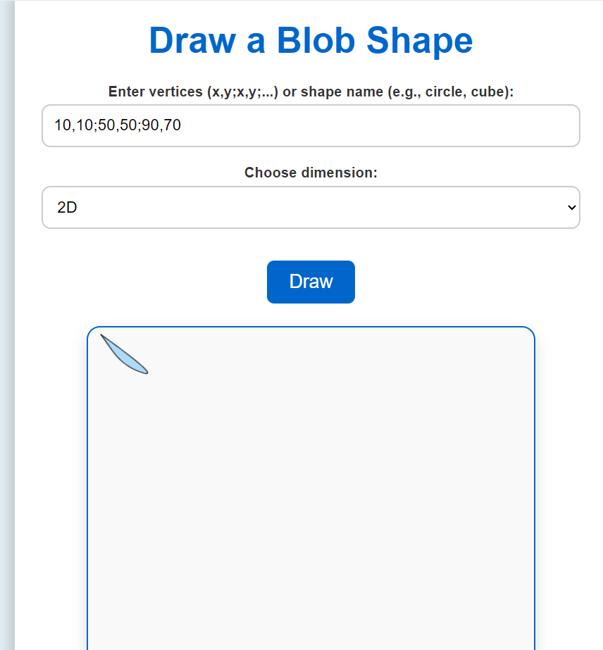

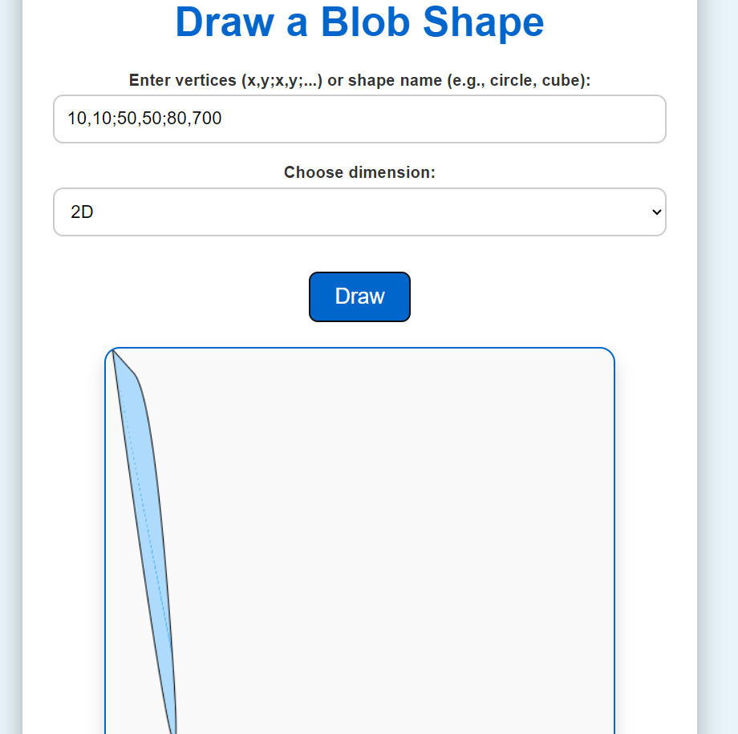

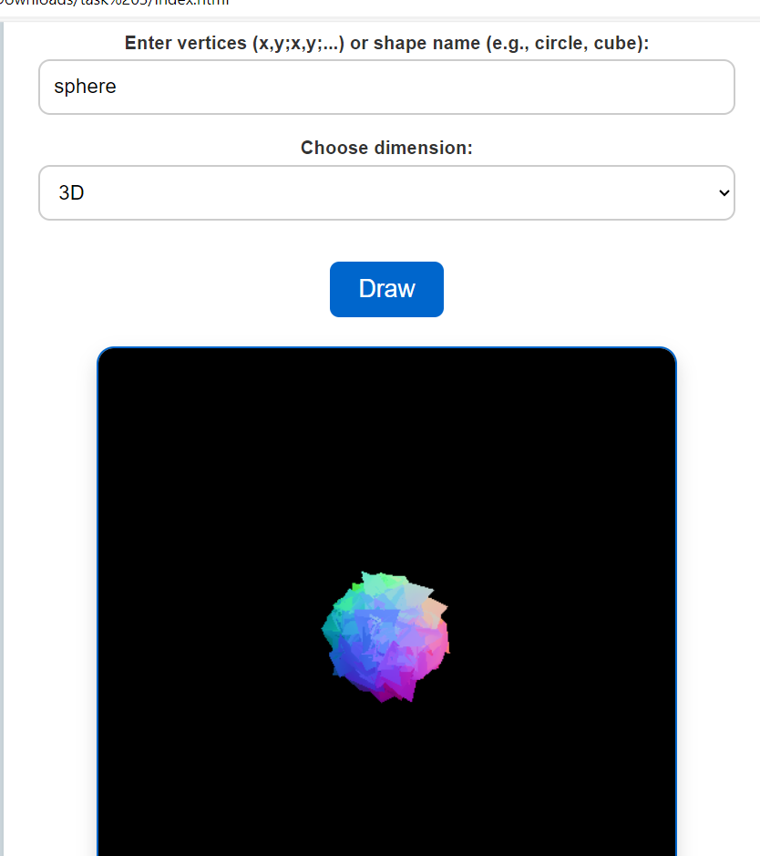

You can access the pseudocode via: [hageranter/Blob-Shape-Drawing](https://github.com/hageranter/Blob-Shape-Drawing)

And try it by .oi

Name: Hager Tarek Saad Anter

ID:20230331943